Lamborghini Assignment

Snippet 1:

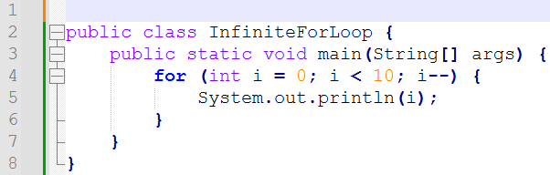

Error: As in for loop integer ‘i’ is initiated with 0 and in condition block of for loop says loop continues till ‘i’ is less than ‘10’ . in Increment and decrement Block of for loop ‘i’ is set for decrement which keeps integer ‘i ’ Always less than 10 . So for loop is infinite

Solution: We need to change decrement into increment.

Snippet 2 :

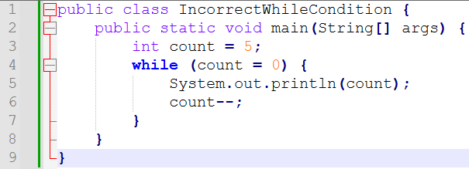

Error: In While loop condition the defining operator is used which denotes variable integer “count ” is assigned value 0 but in condition block of while loop we need to add the equality check operators (== ,<=,>=) .

Solution :

Snippet 03:

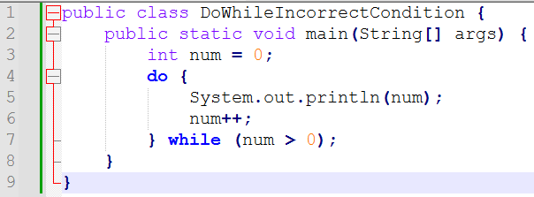

Error : Here integer variable num is initiated with 0 . inside the do – while loop num is set for increment and condition in while loop set as loop continue till num is greater than 0 but due to increment of num variable

Solution:

Snippet 4

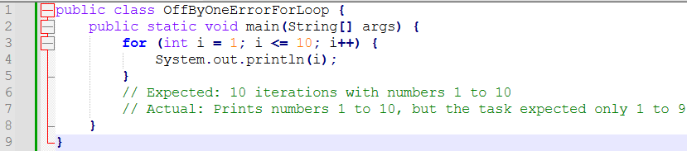

Error : We need to print Number from 1 to 9 but is gets printed upto 10 . in the condition block of for loop the condition is integer variable ‘i’ is less than or equal to 10 it must be only less than 10 then only it will print till 9 otherwise by keeping equality operator as it is need to change the limit 10 into 9.

Solution:

Or

Snippet 5:

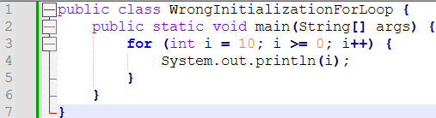

Error : Condition in for loop that ‘i’ is greater than or equal to 0 and integer I is initiated as 10 which keeps variable I always greater than 0 as increment is going on . if we want the order decreasing from 10 to 0 need to convert increment to decrement which gives us output 10 to 0 numbers.

Solution:

Snippet 6

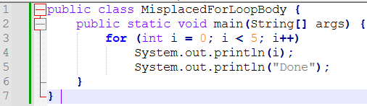

Error : The parenthesis of for loop are missing

Solution :-

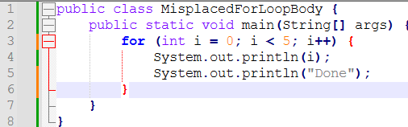

Snippet 7

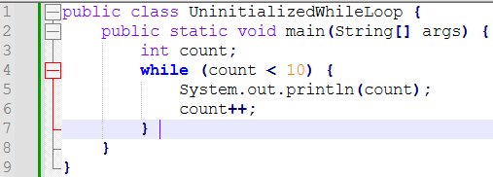

Error : the integer variable count is not initiated is must be initiate with satisfying the while condition

Solution:

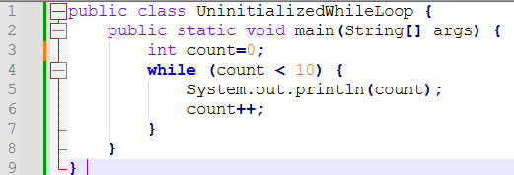

Snippet 8

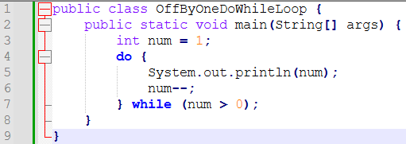

Error: As the integer variable num is initiated with value 1 it must be increasing as the loop flows to increase the value of num variable loop must contain increment operator for num variable but in given snippet there is decrement operator. And also need to add the limit of maximum increment of in while block

Solution:

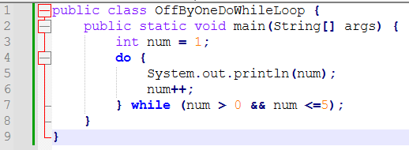

Snippet 9

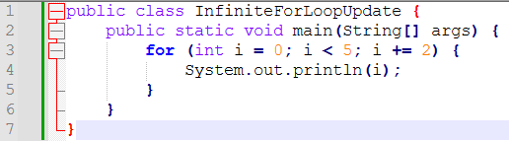

Error: As such there is no error and loop is not running infinitely. But as the increment given in for loop is increment of 2 which prints alternative number if we want to print in normal sequence then need to update increment block for loop

Solution:

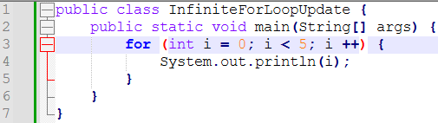

Snippet 10

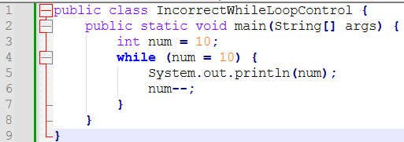

Error: In while loop condition block instead of using equality check operator assignment operator is used

Solution:

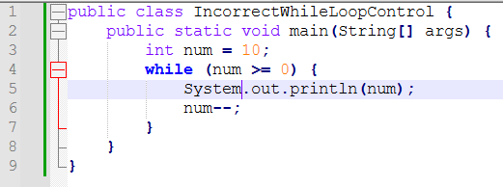

Snippet 11

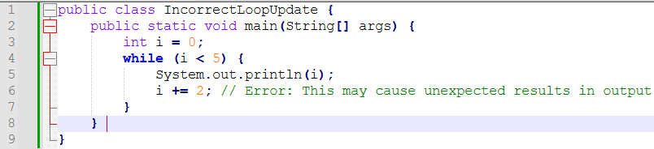

Error: inside the while block integer variable ‘i’ is incremented with alternate numbers.

Solution: 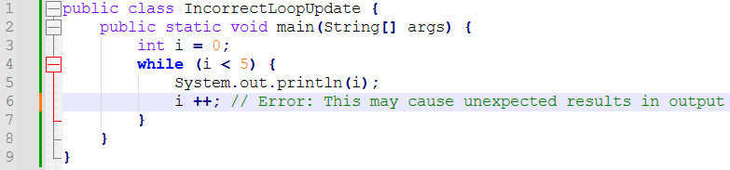

Snippet 12:

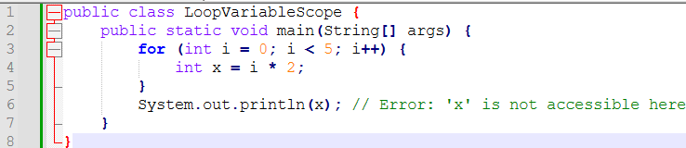

Error: As the integer variable ‘X’ is declared inside the if block so it is defined only for “for” block we need to declare ‘ X’ outside the for loop inside main class.

Solution:

